Brentwood Academy
Parents’ Association Board
2022/2023

Hello Wonderful Brentwood Academy Family,
I just wanted to send a note welcoming you back to school and introducing you to this year’s BAPA board. We are so excited to be partnering with you again to create the best environment possible at Brentwood Academy. Many of you know that we were able to use the proceeds from last year’s Songwriters Night and Auction to provide the money for a new van for BA. We hope that this purchase will enable more non-CDL drivers to offer transportation for their students/ teams. We are planning another successful fundraiser for the Spring in order to help you with some items that you may be wanting or needing, so please be thinking of those items. I would love to hear from you at any time with ways that BAPA can best support you throughout the year. We appreciate all you do to teach, coach and mentor all of our children in the spirit of BA’s mission.
Jason Mathews and I thought it would be helpful for you to have a picture of each of the BAPA board members so that you can place faces with names as we go through the year.
I hope you all have a wonderful school year!
Best,
Darci Belville
BAPA President 2022-2023
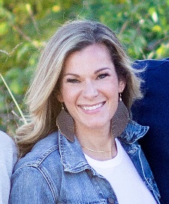
615-397-3371 darcibelville@gmail.com
Darci Belville- President -darcibelville@gmail.com
(Brax- 11th, Brody- 9th, Everleigh- 7th)

Courtney Gilmer-Treasurer-courtgilmer@gmail.com
(Graham- 11th, Riley- 8th)

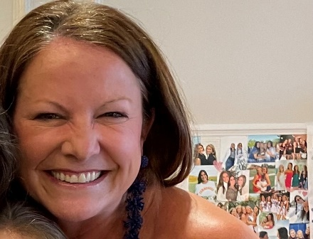 Kara Clark- Secretary- karalynclark@gmail.com
(Cooper- 10th)

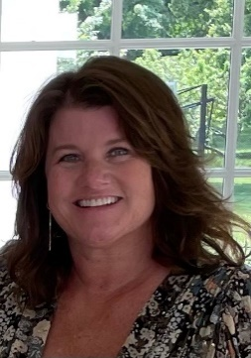 Leigh Ann Witt- Fundraising- leighawitt@yahoo.com
(Char- 9th)

Deanna Cornelius -Fundraising-dj3girls@gmail.com
(Audrey- 9th)

Laura Tucker- Spirit/ Student Life- laura@lauraandcaleb.com
(Micaiah- 11th, Audrey- 10th, Noah- 6th)

Katie Waymire- Spirit/ Student Life- katiewaymire4@gmail.com
(Parkes- 12th, Cash- 9th)

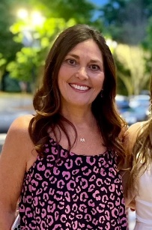 Vera Lee- Hospitality- vmlee1@comcast.net
(Mary Duncan- 10th)

Kelly McMullen- Hospitality- kelly_mc@comcast.net
(Reagan- 11th, Mary Austin- 7th)

Ashlyn Mitchell- Upper School GLP- ashlynsmitchell@gmail.com
(John- 10th)

Alicia Casey- Middle School GLP- aliciacasey@gmail.com
(Hudson- 9th, Tinsley- 6th)

Nikki Stauffer- Faculty Appreciation- nstauffer89@gmail.com (Britton- 8th)

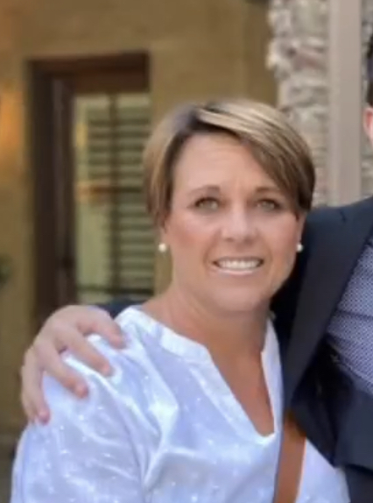
Allison Gardner- Faculty Appreciation- allisongardner@comcast.net (Emerson- 11th)

Kathi West-Christian Life-kathiwest@comcast.net
(Jack- 11th, Quinn- 8th)

Brandon Waymire- BA Dads- waymireb@gmail.com (Parkes- 12th, Cash- 9th)

Zach Watson- BA Dads- Zachwatson615@gmail.com
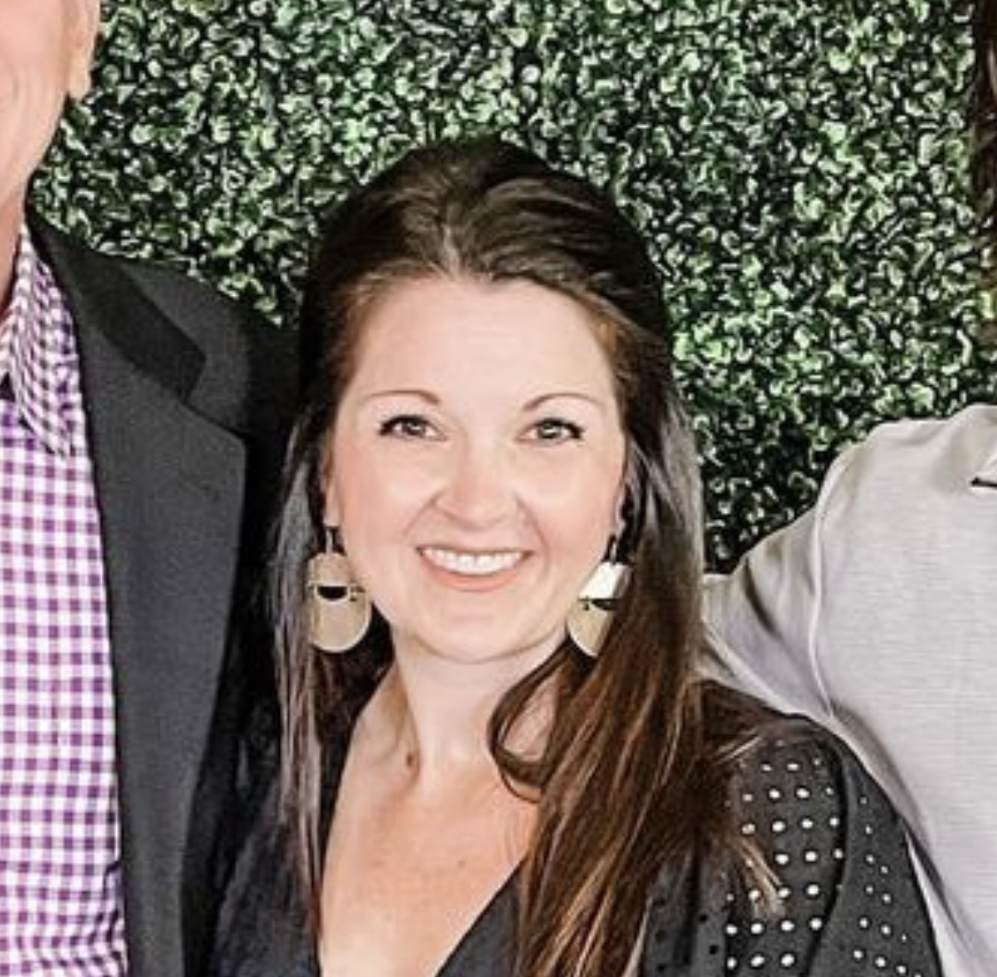
(Hollis- 9th, John Houston- 6th)

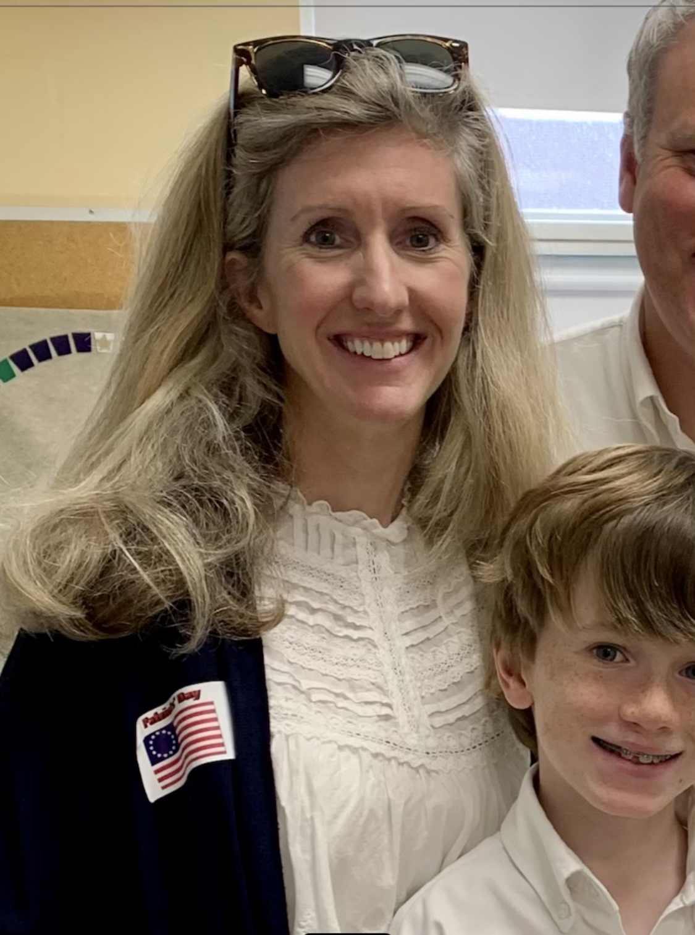
Heather Blankinship-Parent Ambassadors- theblankinships@icloud.com (Ben- 11th, Drew- 11th)

Amy Harr- Parent Ambassadors- amysharr@gmail.com
(Avery- 11th, Ryan- 8th)

Amy Cole- Community Engagement Liaison- momof4coles@gmail.com
(EmmiKate- 11th, Grey- 9th)

